COACHING AT CLIFTON ROBINSONS

Great coaches deliver exceptional environments to meet their players' needs. Everyone needs to start somewhere and so as a Club we want to ensure coaches feel supported, and developed, to help them create these environments.

What does great coaching look like?
Great coaches will be working on these qualities at every level: 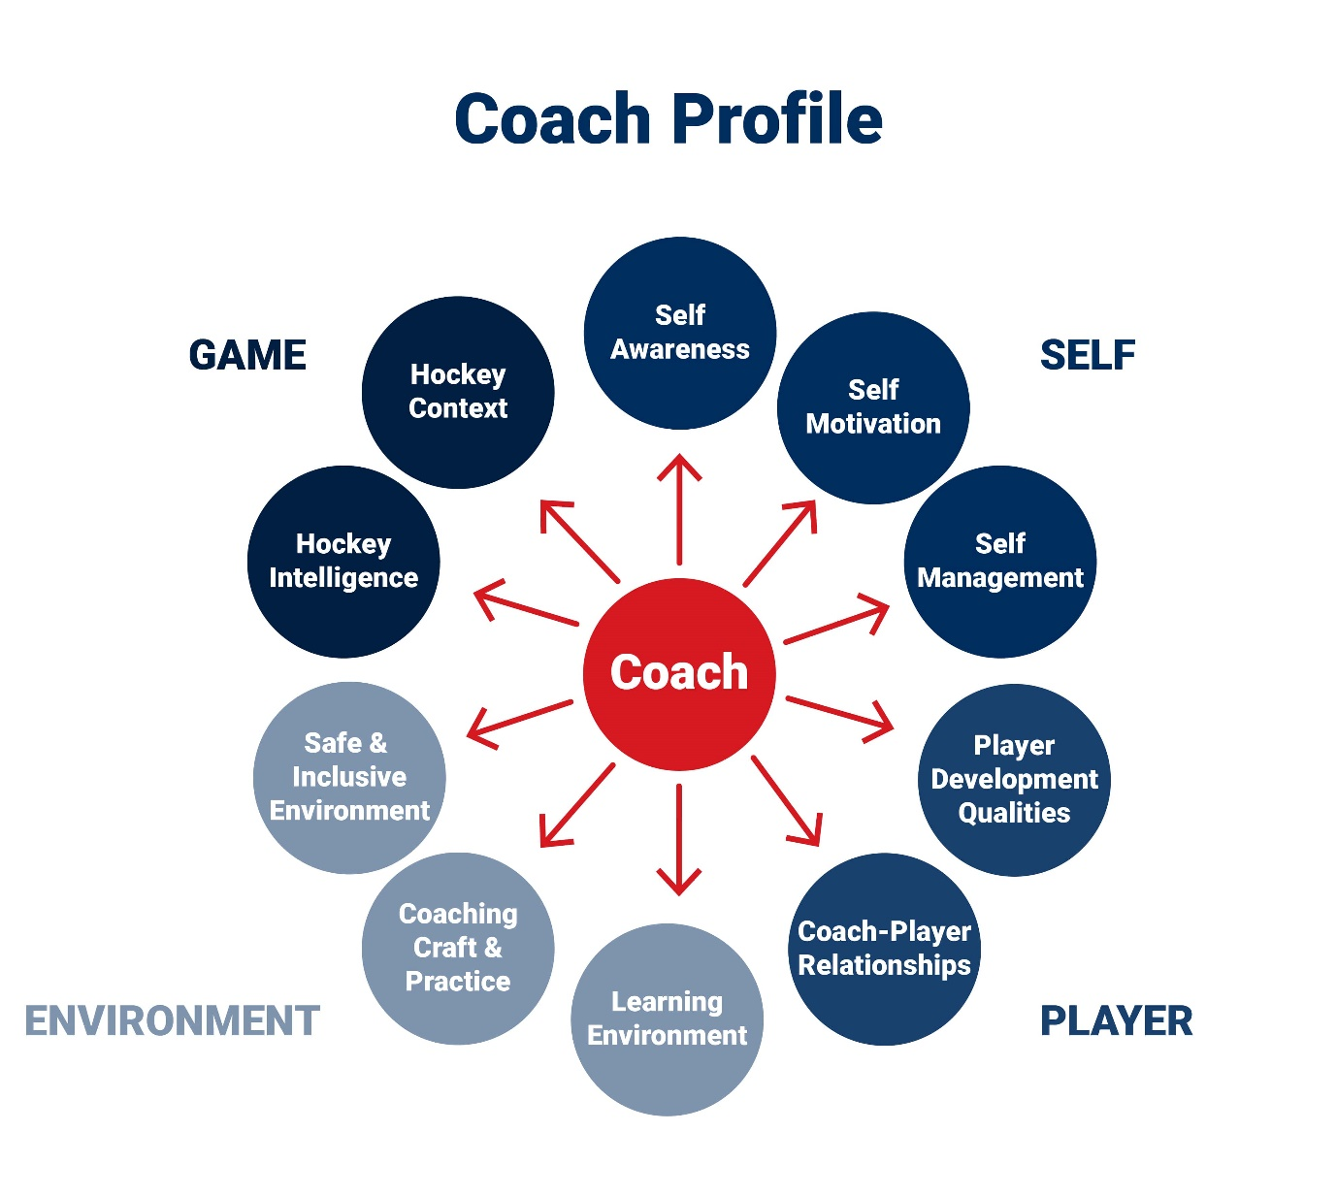

What opportunities are available to develop great coaches?
Coaching starts with small steps and grows as fast as you want it too! Great Britain Hockey have a number of resources available to support both individual coaches and clubs with coach development. There are many ways for you to find out more:
Coaches can also access a guiding and interactive digital document https://viewer.joomag.com/93415-gbh-pathway-digital-document-93415-gbh-pathway-digital-document7/0879373001544631001?short&
that forms part of an annual programme of coach development opportunities. The Offer has been designed to provide support to coaches in identifying the best opportunities for them and their respective pathway, brought to life through videos and animations.

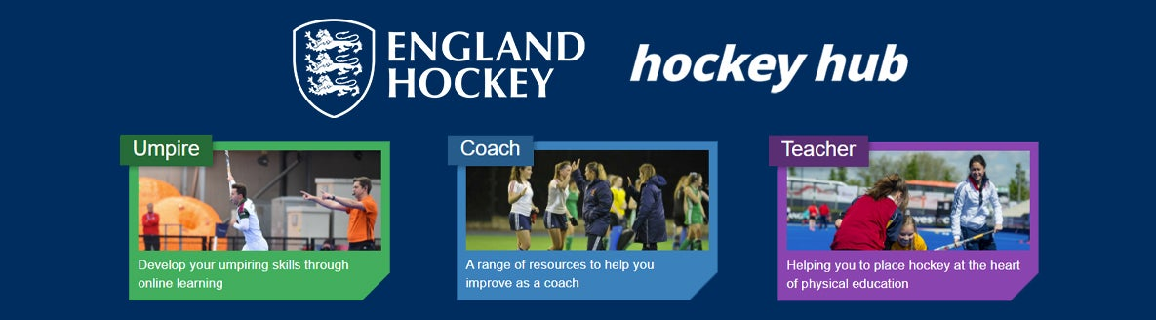
The Hockey Hub https://hockeyhub.englandhockey.co.uk/
is a great FREE one-stop shop, packed full of useful hockey resources including video resources, ideas for your coaching sessions and insights from top coaches.
Whether you coach beginners, work with young, talented players or coach at a one team senior club, there is relevant content available to suit your needs.
The Hockey Hub also has sections for teachers and umpires too! All you need to do is create a free login to access the resources.

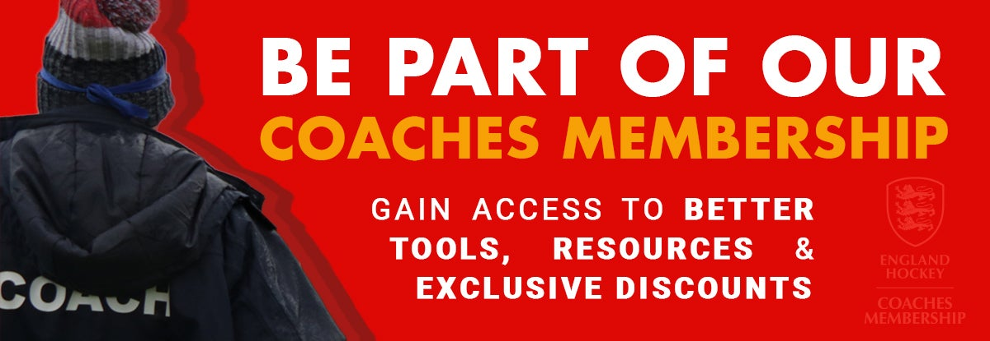
England Hockey’s Coaches' Membership https://hockeyhub.englandhockey.co.uk/coach_membership
If you are not already a member and are doing some coaching, you really should be….membership provides coaches with the essential tools and resources to support coaching delivery and inspire more, better and happier players.
Coaches are hugely important in our great game and this product will ensure our coaches feel valued and empowered. This outstanding all round package includes coaches' insurance in addition to a number of exciting discounts and resources to support and assist coaches in their development.

Through the Club
We currently have 23 qualified coaches at C-R and many helpers but there are plenty of additional opportunities to engage with coaching at many levels in supporting, assisting and lead capacities.
Contacts
If you would like to discuss coaching opportunities or need some more help in understanding what is on offer Juliet Rayden, Mike Leatt, Ian King, Abi Porter or Jamie Mortimore will be happy to hear from you.
Taster Sessions
Building on the in Club session for young coaches the Club ran in summer 2021, there are plans to put on a taster session during 2022 to introduce anyone who want to be involved with or brush up on coaching concepts and practices and to help bring the basics to life.
Useful practical information
More information is available to active coaches in the Club on the website under Admin; Club and then in the drop down box ‘coaching info’. It includes junior session plans, how to include GKs more, some keys areas to consider as session topics and much more. To be able to look at this stuff you will need to be actively coaching at C—R and then contact Mike Leatt for an access code.

