 CLIFTON ROBINSONS HC PLAYER PATHWAY

There are 3 club-based environments for juniors to train and compete.

There is a link between all 3 environments to enable young players to be in the right place with the right opportunities for them.



RELATION TO EH PATHWAY

The new EH Junior Pathway runs from Introducing and Developing Hockey through Talent Development. Performance Development to Elite Performance. The Club pathway maps clearly onto the full length of the EH pathway as progression with entry and exit routes at all stages.

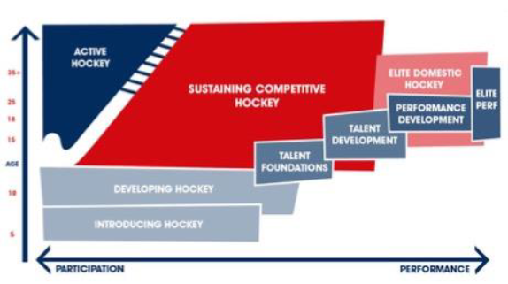



Junior Age Groups and Tiers 2-4 Competition, L 6



Academy Sessions and Tier 1 Competitions, L 5 to 3



Mentoring and L 2



Mentoring and L 1



Specific information about the Junior Age Group Hockey, the Academy and links into Adult Hockey are to be found in separate documents.



**U12s**

U12’s move through to U14s for both genders.

**Women**

At 13, U14s encouraged to play Adult hockey in lower teams.

Players are selected for Academy from U14, mixed age group and Adult playing environments with automatic entry if EH PC .

Players move through age groups and adult teams on merit*. (U18s age group training to be reviewed)

Players that train 2’s or above are automatically in a performance group and managed differently (through mentoring) than in Academy although introduction to mentoring takes place in 3’s.

**Men**

Players attend U14s training. In 2021, (Age group training for U16 to be reviewed)

Junior players invited to attend Men’s Club, Men’s 2/3’s and Men’s 1s training as appropriate and move through adult training on merit*. No Academy equivalent is currently in place, but there is a plan to run a trial sessions and the potential to morph u14s group into an Academy style Group for next season.

*merit covers performance, potential, availability and commitment in competition with all players.